Nama : Muhammad Riveldo Hermawan Putra
NIM : 122140037
Tugas Tambahan Nilai UTS
Link Github: https://github.com/MuhammadRiveldo/Tugas-Tambahan-UTS

01: Single-File Web Applications
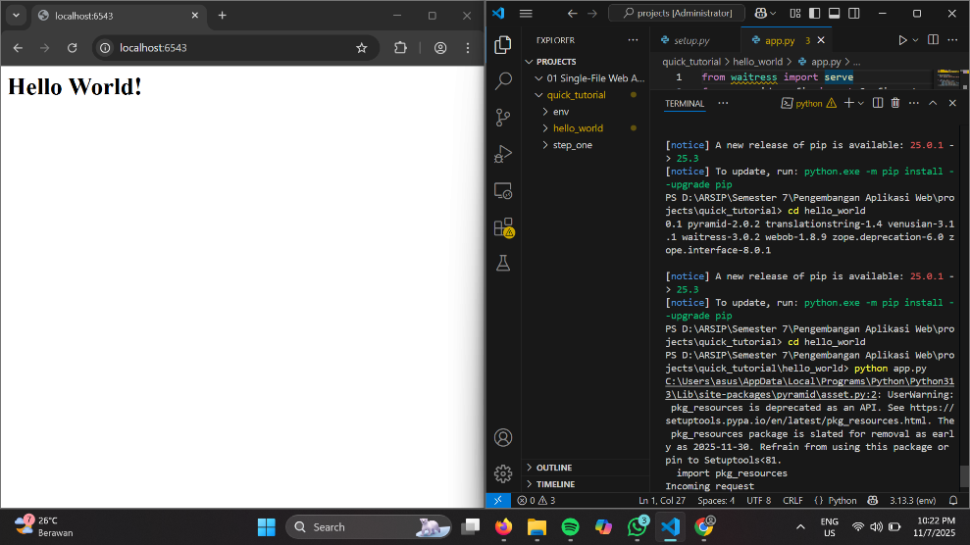
02: Python Packages for Pyramid Applications
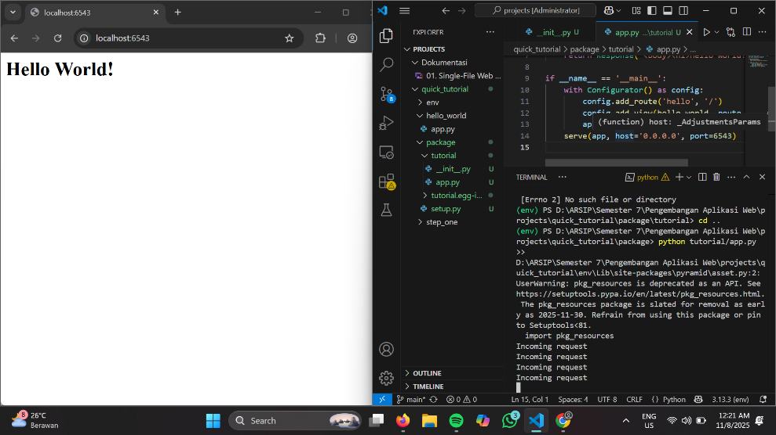
03: Application Configuration with .ini Files
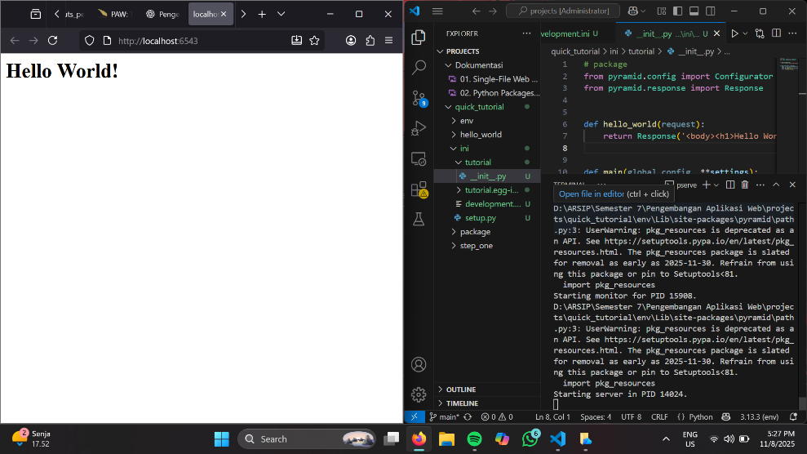
04: Easier Development with debugtoolbar
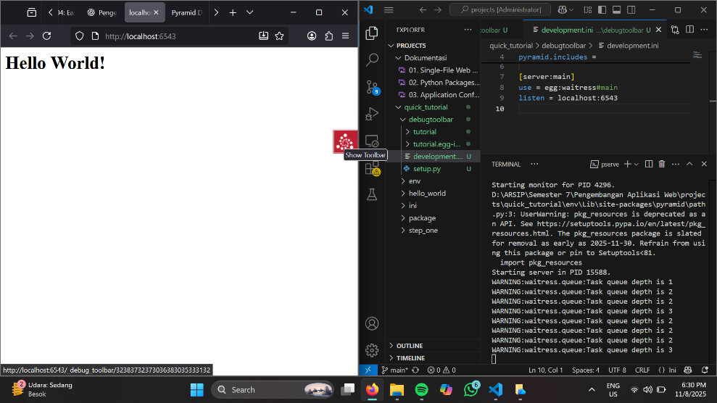
05: Unit Tests and pytest
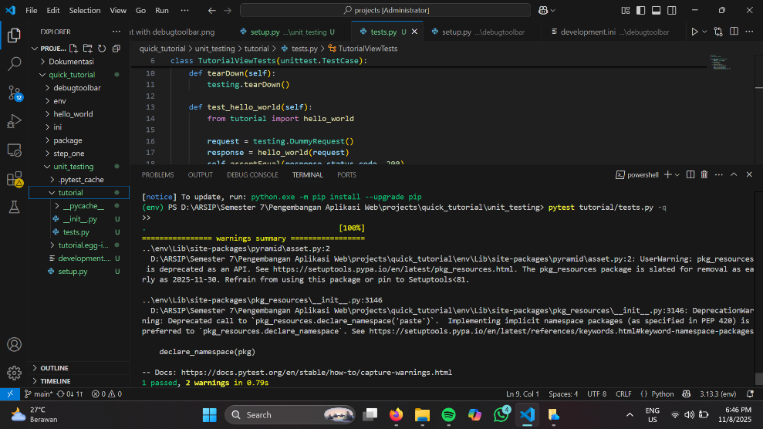
06: Functional Testing with WebTest
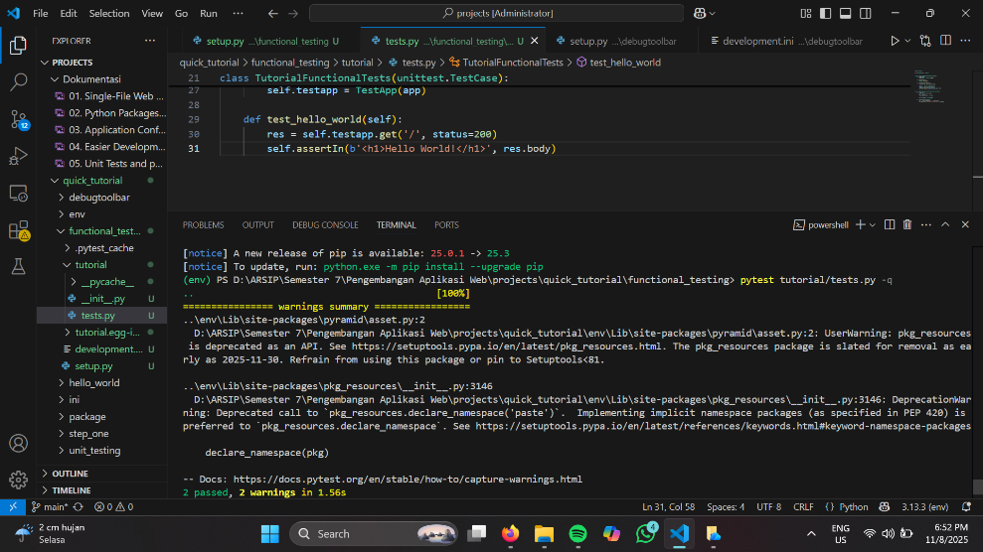
07: Basic Web Handling With Views
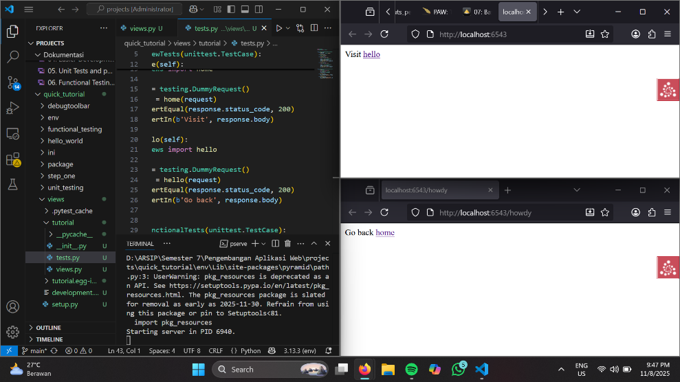
08: HTML Generation With Templating
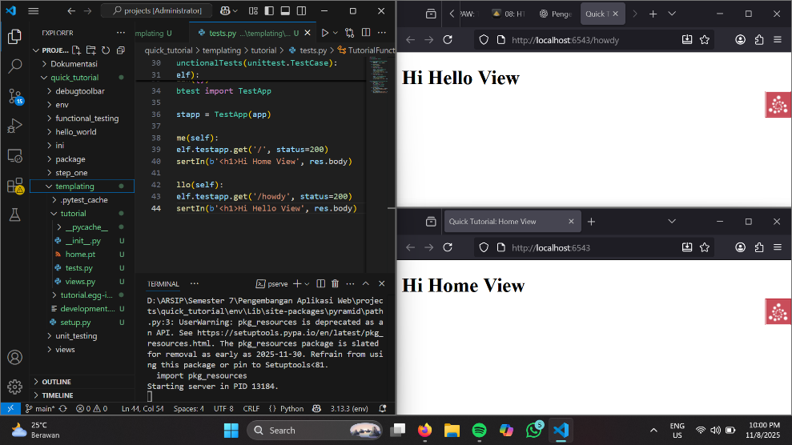
09: Organizing Views With View Classes
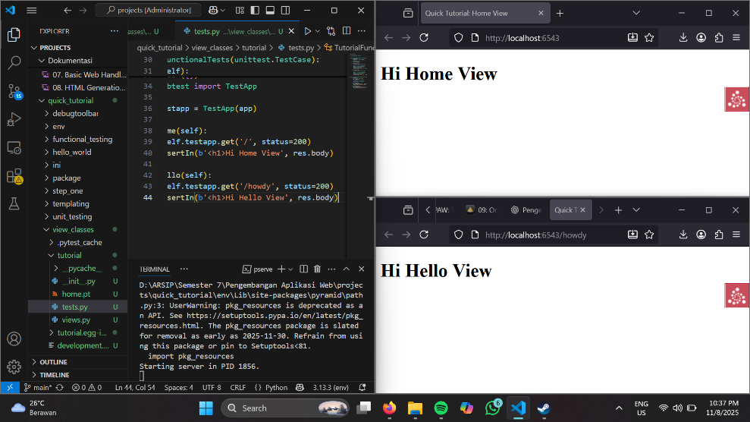
10: Handling Web Requests and Responses
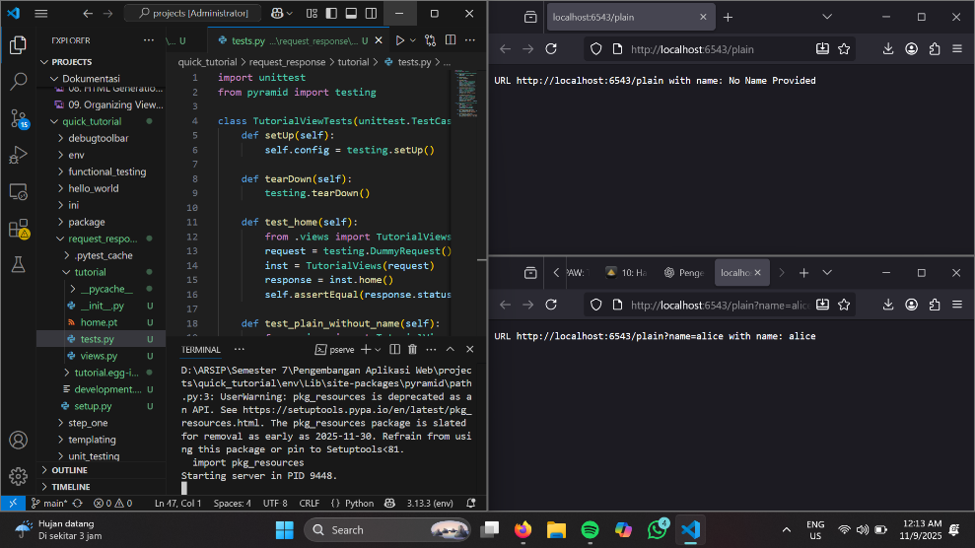
11: Dispatching URLs To Views With Routing
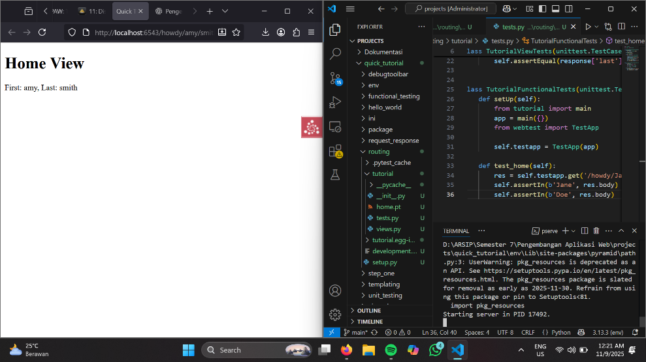
12: Templating With jinja2
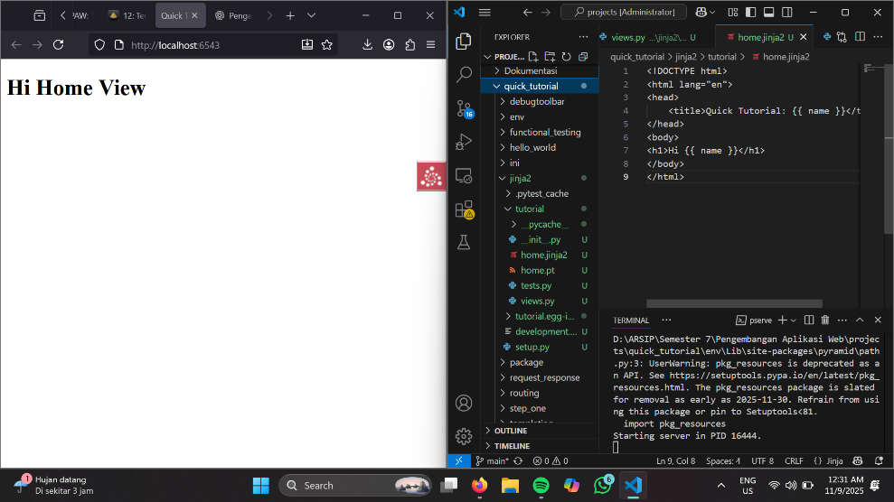
14: AJAX Development With JSON Renderers
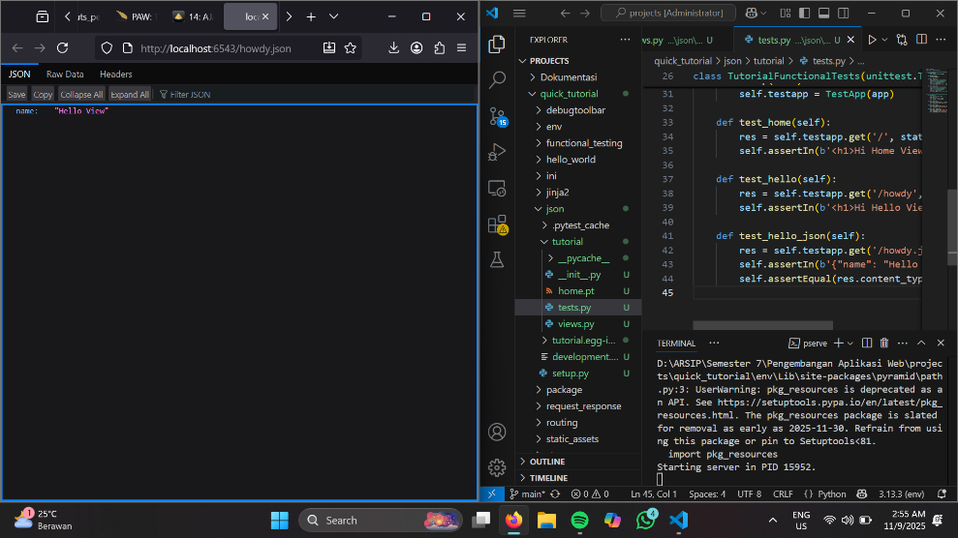
15: More With View Classes
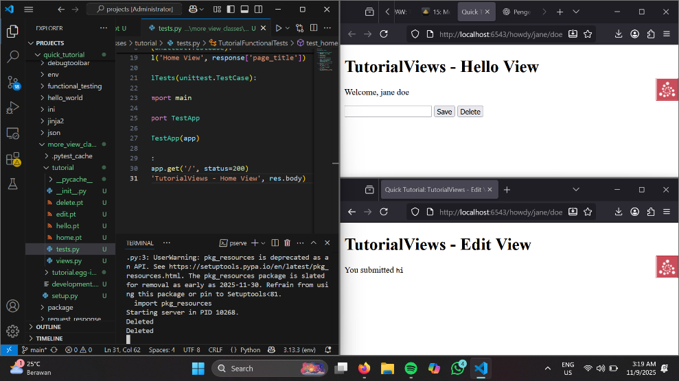
16: Collecting Application Info With Logging
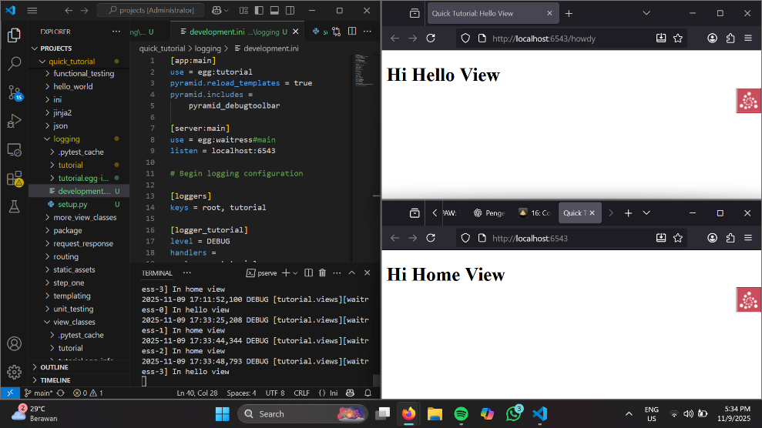
17: Transient Data Using Sessions
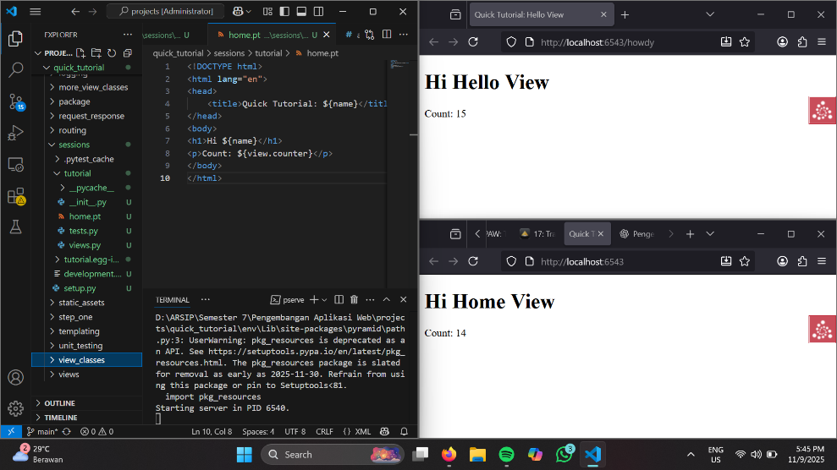
18: Forms and Validation with Deform
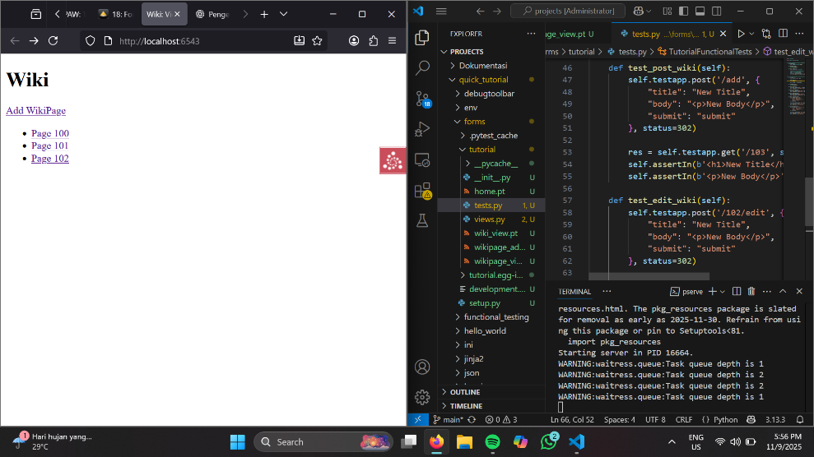
19: Databases Using SQLAlchemy
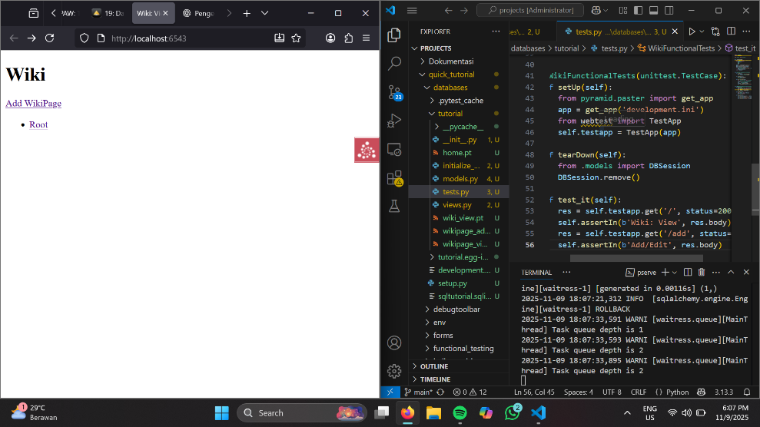
20: Logins with authentication
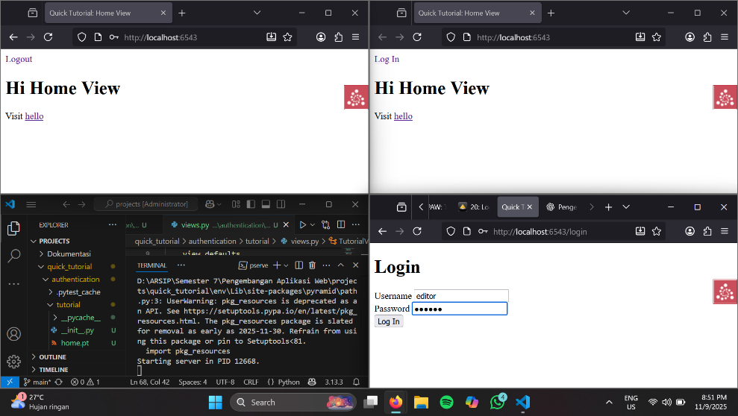
21: Protecting Resources With Authorization